**Social media cards**

**Introduction**

Before Facebook introduced the Open Graph Protocol (OGP), search engine web crawlers, including social media websites, used the internal heuristics of a website to make the best possible guess in terms of the title, description, and preview images to be used for the content.

This often led to social networks having difficulty interpreting the post or information shared in the URL provided. Even today, when you open a link for a website, the preview generated is often an out-of-scale or random image that is possibly embedded somewhere within the web page. This is where meta tags help the end-user take better control of their content.

Over the years, the successful implementation of OGP has led other social media giants, including sister companies owned by Meta, to adopt the protocol to improve the user experience. These platforms have their meta tags that prefix and replace ‘og’ that you have encountered earlier in the course.

**Need for social media cards**

With the number of users and the use of Internet marketing on the rise, user attention is the currency. It is said that a picture is worth a thousand words, and the internet is living proof of this: a caption and image can drive users toward or away from a website. The following image is an example of a social media card for this course:

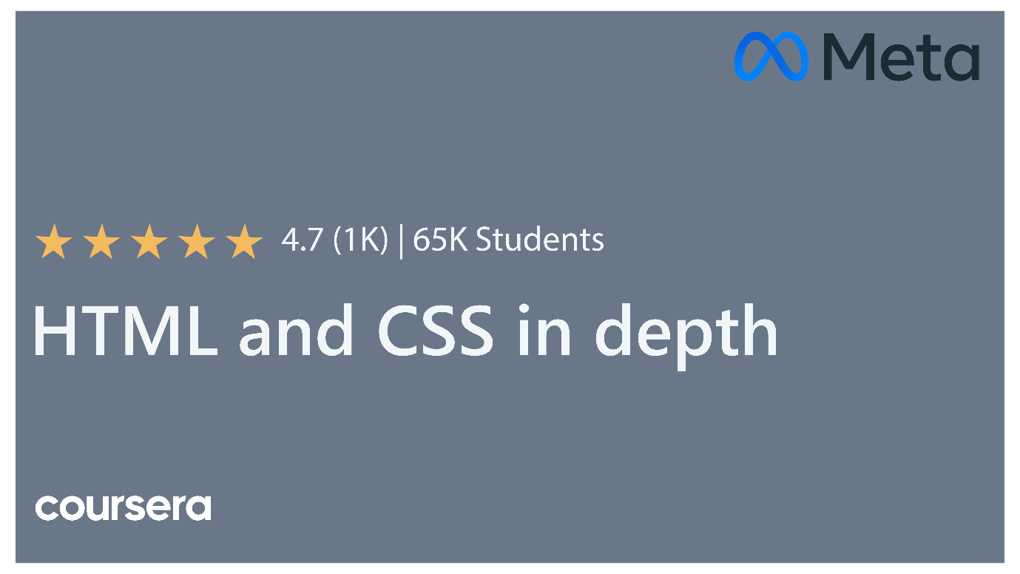

The title and description shared with a URL should summarize the contents of a web page. Sometimes, it may refer to generic information about the entire website. For others, you may tailor the social media (SM) card for a specific page on a website that you’re sharing. The following image is an example of a social card for this course when shared on social media:



**The type OGP tag**

‘type’ is an important OGP tag in SM cards that helps describe the details of a link, like if it’s a book, an article, or a movie. It provides more detailed metadata for specific types. For example, in the case of the music type, you can add details for the song, album, duration, or any other information about the song. For a regular user scrolling through social media, the link provided with the image preview has only one chance and a moment’s attention to make a good impression. In such cases, the role of social media cards becomes very important.

**Social media cards and SEO**

Today's internet is an interconnected graph that is internally a web of URL links, web crawlers, and search engine optimization tools. Together, a web page’s image and title are the store front to invite the user. But social media cards also play an important role in boosting the rankings for the web crawlers used by search engines. They provide the crawlers with the necessary information to build metadata that eventually helps rank websites. Additionally, it also helps track traffic to your website.

While it’s advised to stick to the required tags in social media cards, a developer can also use auxiliary tags that may be suitable. For example, the use of the video tag helps to play in line when displayed on social media websites like Meta.

Meta also has a dedicated page to assist developers that you can find in the additional resources for this section.

**Conclusion**

You should now be more familiar with social media cards, including their importance and benefits. Effective social media cards help to inform Internet users about your website and drive traffic towards it. The extra time a developer spends adding social media tags is worth the effort!